Hamza Salahuddin
Lab-03
Task-04
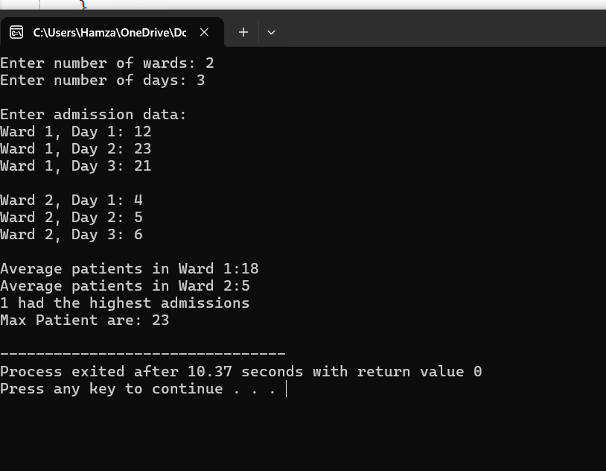
#include <iostream>
using namespace std;

int main() {
int wards, days;
cout<<"Enter number of wards: ";
cin>>wards;
cout<<"Enter number of days: ";
cin>>days;

int** patients=new int*[wards];
for (int i=0;i<wards;i++) {
patients[i]=new int[days];
}

cout<<"\nEnter admission data:"<<endl;
for(int i=0;i<wards;i++)
{
for(int j=0;j<days;j++)
{
cout<<"Ward "<<i+1<<", Day "<<j+1<<": ";
cin>>patients[i][j];
}
cout<<endl;
}

int maxWard = 0, maxDay = 0, maxPatients = patients[0][0];
for (int i=0;i<wards;i++)
{
for(int j= 0; j < days; j++) {
if (patients[i][j] > maxPatients) {
maxPatients = patients[i][j];
maxWard = i;
maxDay = j;
}
}
}

for (int i=0;i<wards;i++) {
int sum = 0;
for (int j=0;j<days;j++) {
sum+=patients[i][j];
}
int avg = sum / days;
cout << "Average patients in Ward " <<i+1<<":"<<avg<<endl;
}

cout<<maxWard+1 <<" had the highest admissions"<<endl;
cout<<"Max Patient are: "<< maxPatients<<endl;

for (int i = 0; i < wards; i++) {
delete[] patients[i];
}
delete[] patients;
}
Task-05

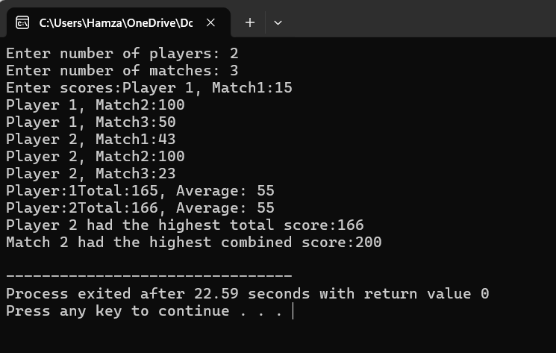
#include <iostream>
using namespace std;

int main() {
int players,matches;
cout<<"Enter number of players: ";
cin>>players;
cout<<"Enter number of matches: ";
cin>>matches;

int **scores=new int*[players];
for (int i=0;i<players;i++) {
scores[i]=new int[matches];
}

cout<< "Enter scores:";
for (int i=0;i<players;i++) {
for (int j=0;j<matches;j++) {
cout<<"Player "<<i+1<<", Match"<<j+1<<":";
cin>>scores[i][j];
}
}
int maxTotal=0,bestPlayer=0;
for (int i=0;i<players;i++) {
int total=0;
for(int j=0;j<matches;j++) {
total += scores[i][j];
}
int avg=total/matches;
cout<<"Player:"<<i+1<<"Total:"<<total<<", Average: "<<avg<<endl;
if (total>maxTotal) {
maxTotal=total;
bestPlayer=i;
}
}
int bestMatch=0;
int maxMatchScore=0;
for (int j=0;j<matches;j++) {
int sum=0;
for (int i=0;i<players;i++) {
sum+=scores[i][j];
}
if(sum>maxMatchScore) {
maxMatchScore=sum;
bestMatch=j;
}
}

cout<< "Player " <<bestPlayer+1<<" had the highest total score:" << maxTotal <<endl;
cout<< "Match " <<bestMatch+1<< " had the highest combined score:" <<maxMatchScore<<endl;

for (int i=0;i<players;i++) {
delete[] scores[i];
}
delete[] scores;
}

